**Step 1**: Download XAMPP and mySQL, the latest versions are the best, but any version can work fine.

**Step 2**: Open XAMPP, start Apache and mySQL.

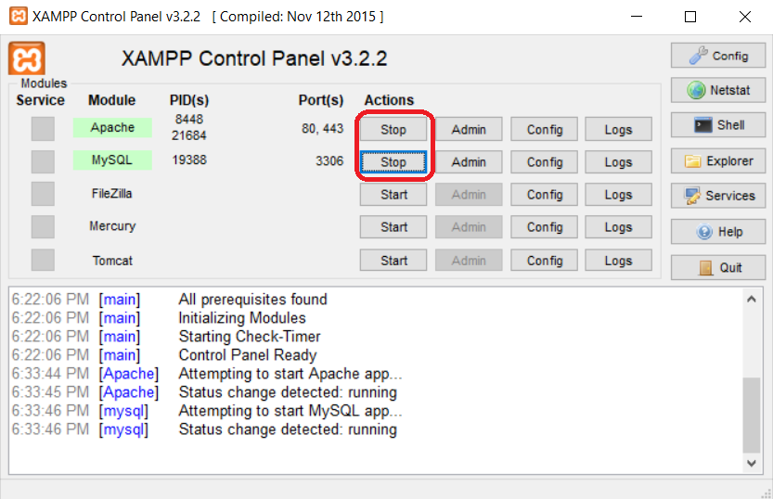

**Step 3**: Copy and paste the whole folder of math_quiz_101 to **C:\xampp\htdocs**.

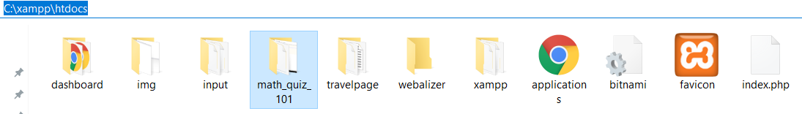

**Step 4**: Type in **localhost/phpMyAdmin** on the address bar.

**Step 5**: Create a database called **survey**, then click **Create** button.

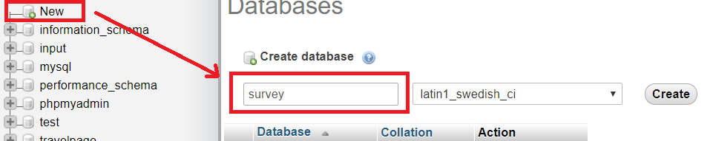

* In the connect.php file, database **survey** is connected to the **localhost**.

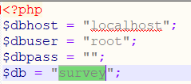

**Step 5**: Inside the **survey** database on **localhost**, upload the database **survey.sql** to phpMyAdmin.

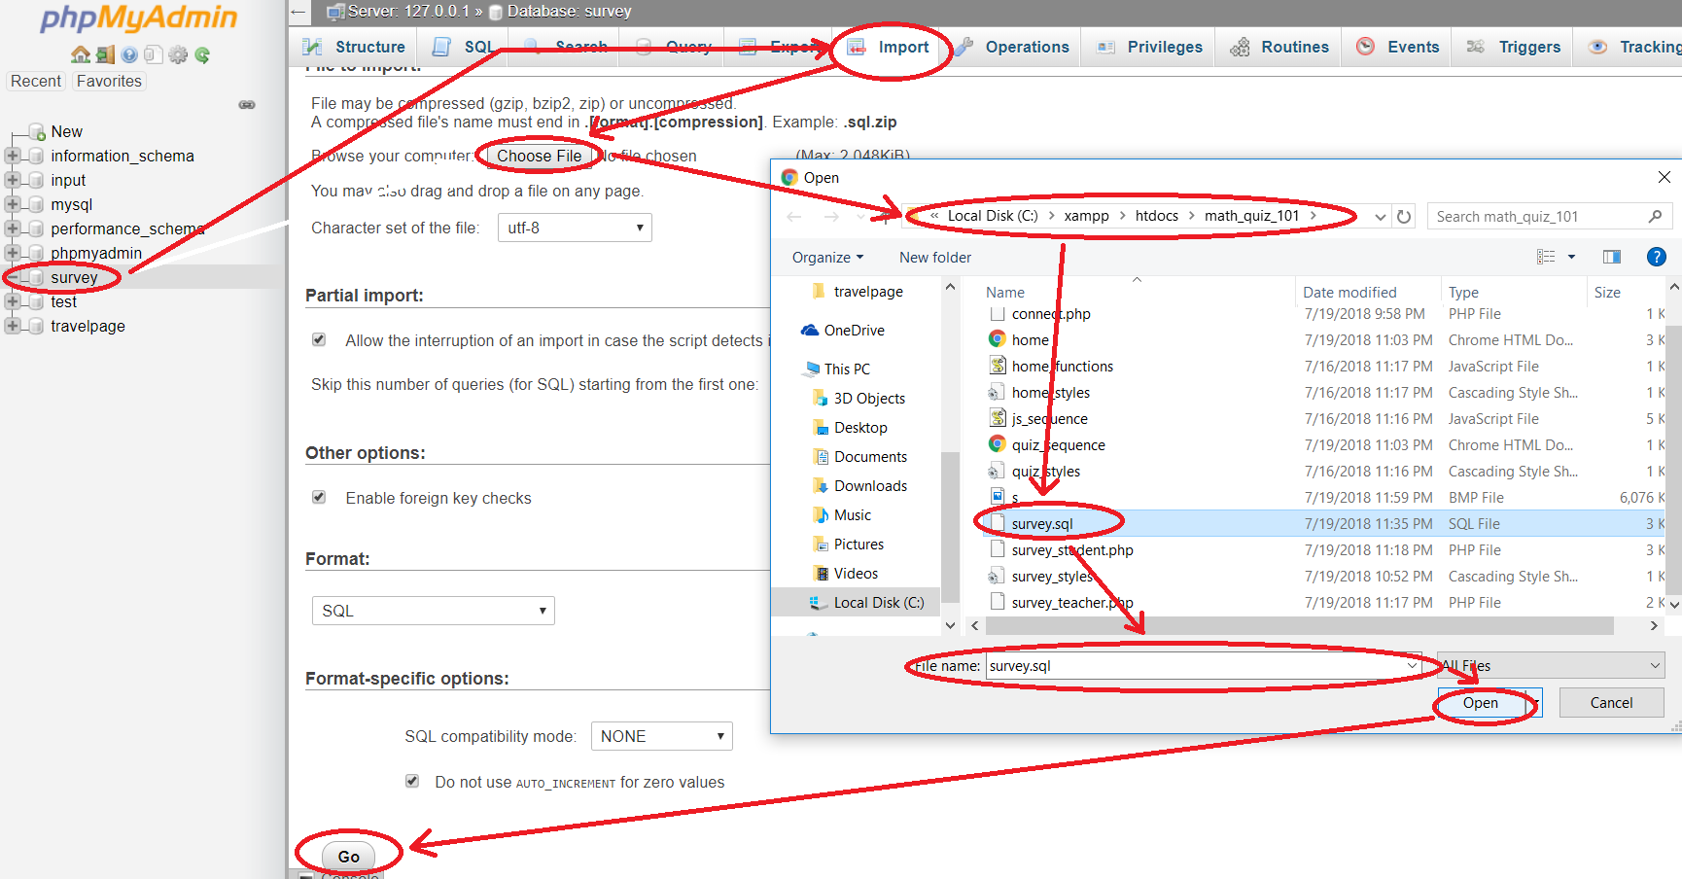

**Step 6**: Great, now let’s look at the student survey.

* Take the survey form on the **survey_student.php** page, then submit it.

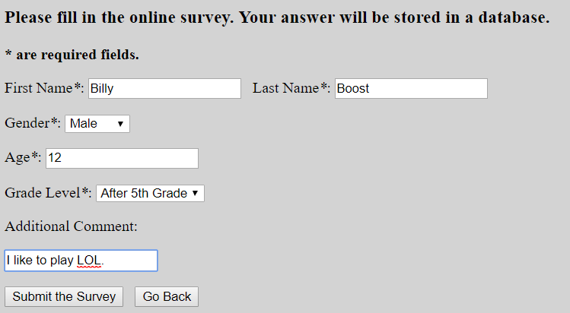

**Step 7**: Check phpMyAdmin see if your newly added information is inserted.

* Yes, it is!

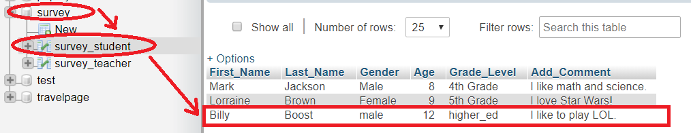

**Step 8**: To export the SQL file, simply go to export, and download the new SQL file.

**Note**: If inserting data from the domain itself fails, just delete the database and retry.